The Utoppia’s recommender system is based on the similarity among users. Begins with the definition of tag fields, e.g.:

Cine, Teatro, Cervezas, Vino, Fiesta, Viajes, Rock ,Pop, Jazz, Techno, RAP, Indie, Correr, Gym, Golf, Basket, Football, Yoga

Every single tag has its own subtags, per example in Rock tag:

Alternativo, Heavy, Country, Grunge

From this, every user rates the tags and subtags according to his/her likes. The rate is boolean, meaning rate or not rate, 1 or 0, like click or not click the button that represents the tag.

With this data, the system creates an n-dimensional space for all tags, every tags made a space where there are users inside. Then, in this space, the system compute the distance between users, and, with that measure, the similarity among users can be calculated.

The tags rating are 85% of weight in the system. The 20% remaining is divided between user’s following (15%) and likes for another user’s plans (5%).

An example is as follow:

1º) The system ask your name:

Your name is:
Tomas
2º) Rate tags and subtags:

Rate cine :
1
Rate drama :
0
Rate comedy :
1
Rate terror :
1
Rate anime :
0

Rate theater :
1
Rate tragedia :
1
Rate comedy :
1
Rate mimics :
0Rate yoga :
1
Rate vinyasa yoga :
0
Rate kundalini yoga :
0
Rate bikram yoga :
1
Rate nidra yoga :
0

Rate drama :
0
…

Rate jazz :
1
Rate cool jazz :
0
Rate free jazz :
0
Rate smooth jazz :
0
Rate acid jazz :
1

Rate yoga :
1
Rate vinyasa yoga :
0
Rate kundalini yoga :
0
Rate bikram yoga :
1
Rate nidra yoga :
0

3º) The system computes which users with plan are closer to Tomas:

Similar users with plan :
Jesus
Alba
Nuria
Alvaro
Adolfo
Maria
Monica
Jaime
Marta
Juan
4º) Do you want to join to user plan?

5º) The system ask for following or likes:

Follow user Jesus?
1

Follow user Alba?
1

Follow user Nuria?
1

Follow user Alvaro?
0
…

Do you like the user Jesus plan?
1

Do you like the user Alba plan?
0

Do you like the user Nuria plan?
1

6º) The system recompute the similarities

We can show this process with few graphs:
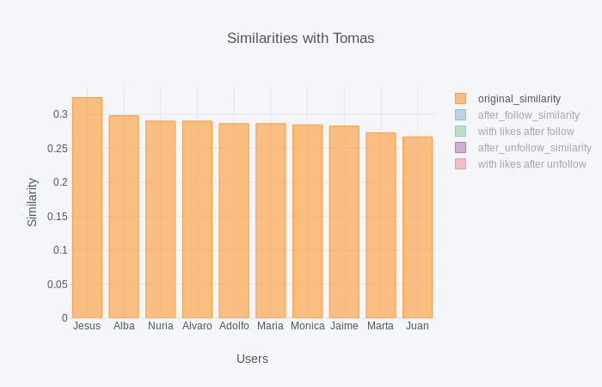
The original similarities can be shown as follow:
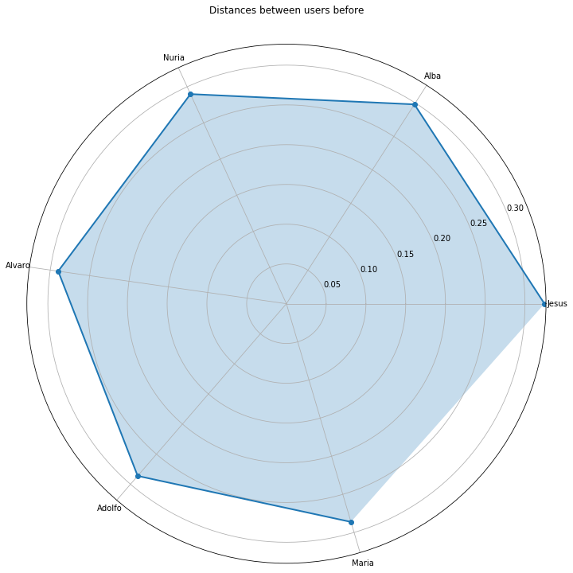

This is the original similarity among users at the beggining, when an user is registered. The next plot shows how change similarities when Tomas is following other users:

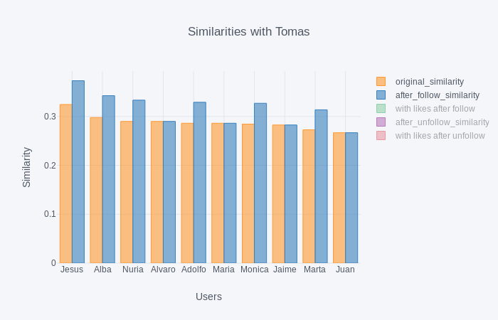

After all interactions among users, the final similarities are showing in the next plot:
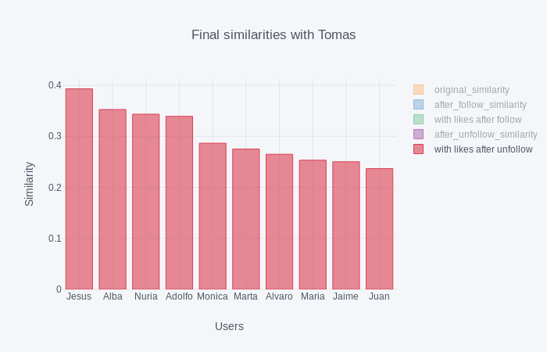

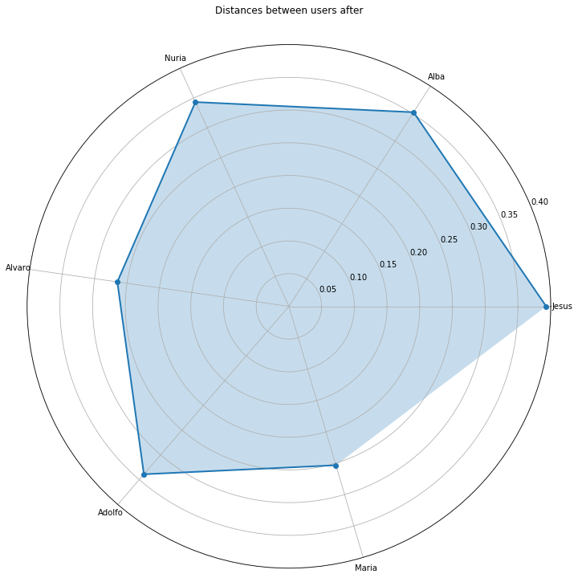

As we can see, the similarities have changed, so the recommendation has changed too, because the differences.
From this point the recommender system is upgraded with new users and new interactions.

